THE CELL CYCLE WORKSHEET Name: _______________

Matching: match the term to the description
A. Interphase | B. Prophase | C. Metaphase | D.Anaphase | E. Telophase

____ 1. The sister chromatids are moving apart.

____ 2. The nucleolus begins to fade from view.

____ 3. A new nuclear membrane is forming around the chromosomes.

____ 4. The cytoplasm of the cell is being divided.

____ 5. The chromosomes become invisible.

____ 6. The chromosomes are located at the equator of the cell.

____ 7. The nuclear membrane begins to fade from view.

____ 8. The division (cleavage) furrow appears.

____ 9. The chromosomes are moving towards the poles of the cell.

____ 10. Chromatids line up along the equator.

____ 11. The spindle is formed.

____ 12. Chromosomes are not visible.

____ 13. Cytokinesis is completed (as next cycle begins).

____ 14. The cell plate is completed.

____ 15. Chromosomes are replicated.

____ 16. The reverse of prophase.

____ 17. The organization phase

.
Fill in the blank: Some will be used more than once.
A. Prophase | D. Metaphase | G. Chromatid | J. Spindle fiber
B. Interphase | E. Anaphase | H. Cytokinesis | K. Cell plate
C. Telophase | F. Centromere | I. Mitosis

______________18. What phase are daughter cells in as a result of mitosis?

______________19. During what phase of mitosis do centromeres divide and the chromosomes move toward their respective poles?

______________20. What is the phase where chromatin condenses to form chromosomes?

______________21. What is the name of the structure that connects the two chromatids?

______________22. In a chromosome pair connected by a centromere, what is each individual chromosome called?

_____________23. What are the two parts of cell division?

______________24. What structure forms in prophase along which the chromosomes move?

______________25. Which phase of mitosis is the last phase that chromatids are together?

______________26. Which phase of the cell cycle is characterized by a non-dividing cell?

______________27. What structure is produced when protein fibers radiate from centrioles?

______________28. What forms across the center of a cell near the end of telophase?

______________29. The period of cell growth and development between mitotic divisions?

______________30. What is the phase where cytokinesis occurs?

The diagram below shows six cells in various phases of the cell cycle. Note the cells are not arranged in the order in which the cell cycle occurs. Use the diagram to answer questions 1-7.
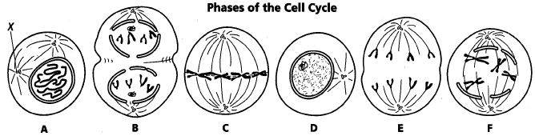

- Cells A & F show an early and a late stage of the same phase of the cell cycle. What phase is it?
- Which cell is in metaphase?
- Which cell is in the first phase of M phase (mitosis)?
- In cell A, what structure is labeled X?
- List the diagrams in order from first to last in the cell cycle.
- Are the cells depicted plant or animal cells?
        - Explain your answer.

  - If it were the other type of cell what would be different in the diagrams?

- What is the longest phase of the cell cycle?

- Why is mitosis important?

- Predict what would happen if an individual had faulty spindle fibers.

- Predict what would happen if cytokinesis was skipped.

